­­

Design Document

**Battleship application**

**Table of Contents**

1 Introduction 3

2 Technologies and requirements 3

3 Overview 3

In scope (must-have) 3

4 Workflow 4

UI Design Considerations 4

General Constraints 5

5 Documentation 5

Design document 5

Readme 6

6 Send completed task to Akvelon 6

# Introduction

This application is used to test frontend candidates. Your hr-specialist is your point of contact for questions, passing the task to Akvelon etc. Please keep in mind that this is the project that will be used to evaluate your skills. The project will be evaluated as if you are delivering it to a customer. We expect you to make sure that the app is fully functional and doesn’t have any obvious missing pieces. Please ensure that you’ve read and understood all requirements.

# Technologies and requirements

* Frontend: javascript or TypeScript, React or AngularJS. You may feel free to use Redux, LESS, or modern ES6 javascript features if you’d like.
* Backend: no

# Overview

## In scope (must-have)

The application is a partial Battleship game as a web app. The computer has positioned five ships of various sizes on a 10x10 board. Each ship must be placed horizontally or vertically, completely on the board, without overlapping another ship. The player cannot see the ship locations. Each round, the player “fires” at a board position of his choosing. The computer indicates if this was a “hit” or a “miss”. When all tiles of a particular ship have been hit, the computer indicates that the entire ship has been sunk. When the player has sunk all of the ships, the game is over. Obviously this game would be more fun if the player had his own ships and the computer were firing back, but we’ll leave that out for simplicity. In other words, we are only implementing the turns for Player 1, not for Player 2. You may use the provided JSON data (see below) indicating the position of the ships. You should produce a web app for this game as described, according to the provided mocks. The game should be responsive and mobile-friendly, so that it may be played on an iPhone 5-sized screen (320x568) up to a desktop browser (approx. 1440x1024). It’s not necessary to save game state or anything like that.

Ship layout data:

{

"shipTypes": {

"carrier": { "size": 5, "count": 1 },

"battleship": { "size": 4, "count": 1 },

"cruiser": { "size": 3, "count": 1 },

"submarine": { "size": 3, "count": 1 },

"destroyer": { "size": 2, "count": 1 }

},

"layout": [

{ "ship": "carrier", "positions": [[2,9], [3,9], [4,9], [5,9], [6,9]] },

{ "ship": "battleship", "positions": [[5,2], [5,3], [5,4], [5,5]] },

{ "ship": "cruiser", "positions": [[8,1], [8,2], [8,3]] },

{ "ship": "submarine", "positions": [[3,0], [3,1], [3,2]] },

{ "ship": "destroyer", "positions": [[0,0], [1,0]] }

]

}

# Workflow

## UI Design Considerations

Please use assets provided in the archive “assets”. Find sample screens for different resolutions below.

Desktop:

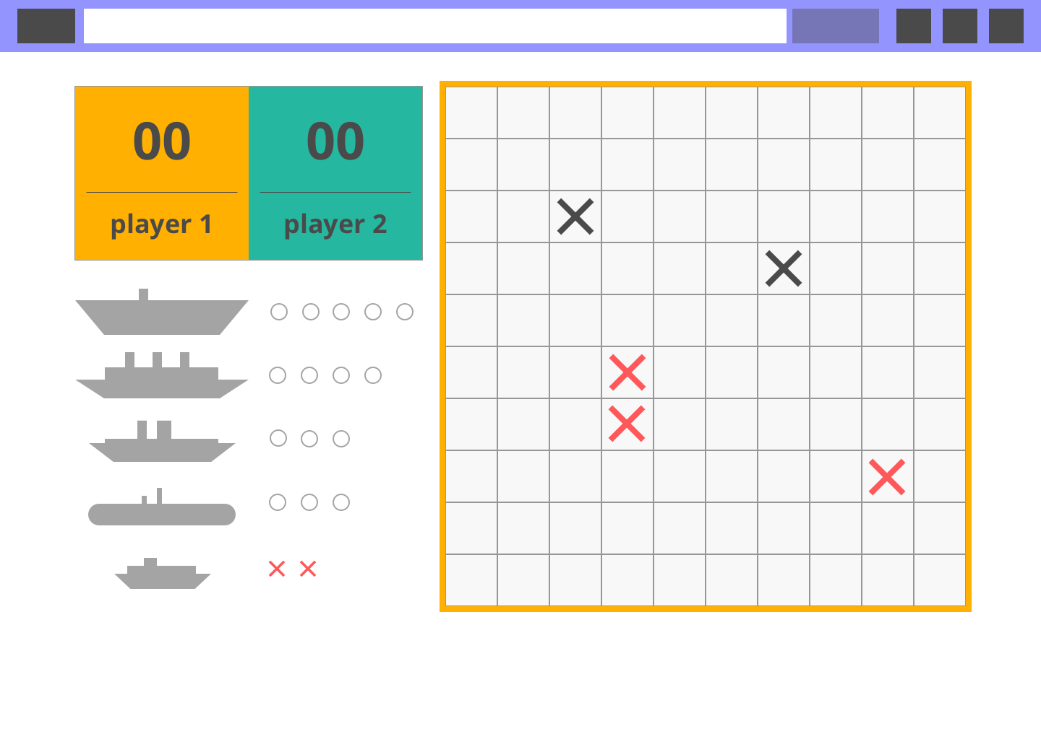

Mobile:

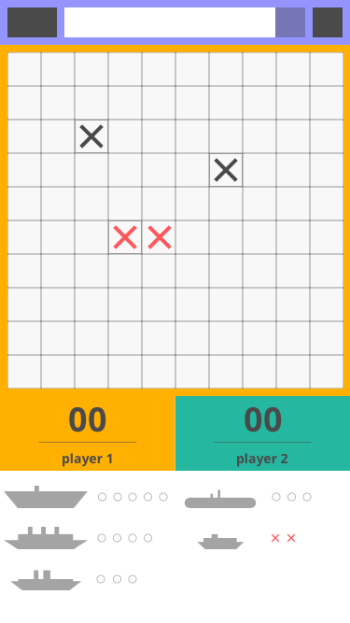

Tablet:

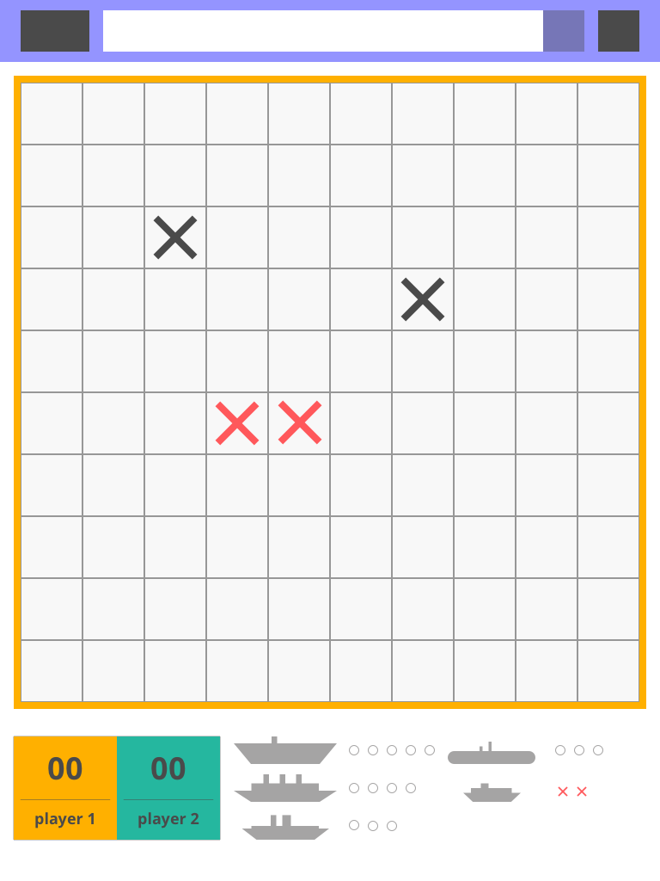

## General Constraints

**No plugin** (flash, silverlight) should be used for development.

# Documentation

## Design document

Design Document contains information concerning all technical solutions and application architecture. Next items are as example:

* DB scheme;
* Application modules description (Logger, DB Access Layer, controllers, views, models, managers and so on);
* Architecture scheme;
* Error handling;
* Services;
* Etc.

The only requirement is to clarify architecture and developer’s intentions, there is no requirement to follow some standard (like UML).

This document should be in English.

## Readme

Explains how to run the app. Should be in English.

# Send completed task to Akvelon

In order to send the task to Akvelon for checking please be ready to provide repository with the code (bit bucket private repository), repository should have:

1. Code
2. Design document
3. Readme
4. Short video demo showing the main screens of working app and main scenarios.